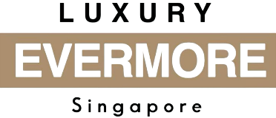
LuxuryEvermore.com
Luxury Evermore Pte Ltd
18-06, 2 Marina Blvd
Singapore 018987
Contact: +65 84023748
Email: contact@luxuryevermore.com
Bill To:
{{Buyer}}
Sales Receipt
Transaction Information
Receipt # | {{Receipt_no}}
Date | {{Date}}
Payment Method | {{Payment_method}} ({{Payment_status}})
Items Purchased
Image | Item Name | Inclusions | Amount
{{Image}} | {{Item_name}} | {{Inclusions}} | {{Amount}} {{Currency}}
Total Amount Paid: ${{Total_amount}} {{Currency}}

Terms of Sale
All sales are final due to the secondhand nature of the items. Items sold are strictly non-refundable and non-exchangeable. By completing the purchase, the buyer confirms acceptance of the item’s condition, authenticity status, and description at the time of sale. Refunds will only be considered if the item is conclusively proven to be non-authentic by the brand itself or a mutually agreed, recognized third-party authentication service with a proven track record.

Additional Notes
{{Additional_notes}}

Authorized Signature

Thank you for shopping at Luxury Evermore!

